## Project Report On

"**SHEET METAL CUTTING USING PNEUMATIC DOUBLE ACTING CYLINDER**"

Submitted By

## Talewar Narayan Diliprao

## Sontakke Satish Devrao

## Dumane Kailas Nandkishor

Under The Guidance Of

## Prof. D.S.Pimpalgaonkar

## C:\Users\ankit\Desktop\srtmu logo.jpg

**Department Of Mechanical Engineering Mahatma Gandhi Mission's College Of Engineering, Nanded**

**Affiliated to**

**Swami Ramanand Teerth Marathwada University, Nanded, Maharashtra (2017-2018)**

**CERTIFICATE**

This is to Certify that the Project Report Entitled

## "SHEET METAL CUTTING USING PNEUMATIC DOUBLE ACTING CYLINDER"

Submitted By

## Talewar Narayan Diliprao

## Sontakke Satish Devrao

## Dumane Kailas Nandkishor

Under The Guidance Of

## Prof. D.S. Pimpalgaonkar

As a Partial Fulfilment of Degree **"Bachelor of Engineering in Mechanical"**



To

Department Of Mechanical Engineering

Mahatma Gandhi Mission's College Of Engineering, Nanded

Affiliated to

## Swami Ramanand Teerth Marathwada University

Nanded, Maharashtra,(India)

## Prof. D.S. Pimpalgaonkar Dr. J.S.Sidhu

Guide Head Of The Department

## Dr. Mrs. G.S. Lathkar Director

**M.G.M.'S COE, Nanded**

**Acknowledgement**

I avail this opportunity to express my deep sense of gratitude and whole hearted thanks to my guide **Pro. D.S. Pimpalgaonkar f**or giving his valuable guidance and affectionate encouragement to complete this project and also thanks to project coordinator **Prof. Shaikh M.H.**

I also acknowledge my overwhelming gratitude and sincere thanks to our head of department, **Dr. J.S. Sidhu**.

Also I would like to thank **Prof. N. A.Kadam & V.D.Deshmukh** who solved my problems whenever I went to him & for his guidance for this project since related to his field.

I also express my sincere thanks to our director madam **Dr. G.S. Lathkar**, who always

inspired me.

At last I would like to express my gratitude to all teaching and non teaching staff, who

have extended their support and helped me directly or in direct in completing this project.

# CONTENTS

|  |  |  |  |
| --- | --- | --- | --- |
| **Chapter No.** | **Name Of Chapter** | **Page No.** |  |
| 01 | Introduction | 01 |  |
| 02 | Literature Survey | 08 |  |
| 03 | Need for Automation | 13 |  |
| 04 | Specifications | 14 |  |
| 05 | Main Components | 15 |  |
| 06 | Construction | 28 |  |
| 07 | Working | 37 |  |
| 08 | Results and Discussions |  |  |
| 09 | Conclusions | 39 |  |
| 10 | Future Scope | 40 |  |
| 11 | References | 41 |  |
| 12 | Research paper | 42 | |

**ABSTRACT**

Pneumatic systems are extensively used in a wide range of industries and factories and manufacturing sector entities. Pneumatic systems are noted for their simplicity, reliability and ease of operation. Also they are suitable for fast and rapid application of force. The purpose of this project is to design a simple, easily operated pneumatic sheet metal cutting machine which is sturdy and strong. A pressure of 8-10 bar is enough for operating the unit. The pressurized air passing through the tubes to the cylinder, forces the piston out whose power through the linkage is transmitted to the punch. The work piece thus got is for required dimensions and the piece can be collected through the land clearance provided. This enables us to use different type punch dies resulting in a wide range of products. According to the work material the operating pressure can be varied.

We are using scissors for simple sheet metal cutting. It is a manual method so that sheet metals are to be wasted sometime because of the mistakes that happened such as wrong dimensions etc., and also even a simple cutting may take long time.Hydraulic machines are also available for sheet metal cutting. But this method is used for only heavy metal cutting and its cost is very high.We are using a pneumatic system for sheet metal cutting in a easy way. It is operated by a pneumatic hand lever of two ways control valve. Control valve is handled by worker who uses compressor for movement of piston in cylinder..

# INTRODUCTION

* Nowadays, technology development demands efficiency of time and energy in all fields in order to create a product that can compete in the global market.
* Breakthrough innovations are needed to survive in global market.
* We all know about sheet metal working processes.
* Sheet metal contributes a wide range of applications in many industries, one such example is automobile and aerospace industries.
* Also it is known that sheet metal has sharp edges which may tear off the skin while working on it.
* Hence to avoid such kind of situation we have designed a automatic sheet metal cutting machine.
* Use of sheet metals are nowadays in furniture, shelves or cupboards etc. Sheet metal is simply a metal formed into thin and fat pieces. The thickness of sheet is called its gauge. The sheet metal plates having thickness above 6mm falls into plate category.
* There are many metals that can be made into sheet metal like Al,Br,Cu etc.
* Sheet metals are used in car bodies, medical tables etc.

# 01

**SHEET METAL OPERATIONS:**

Shearing Bending Drawing Squeezing

## A) Shearing:

1. Punching (piercing) :

It is sheet metal cutting operation in which circular holes are produced by punch and die. Material punched out is removed out as waste. Punching is a forming process that uses a punch press to force a tool, called a punch, through the workpiece to create a hole via shearing. Punching is applicable to a wide variety of materials that come Titanium nitride coated industrial punches using cathodic arc deposition technique in sheet form, including sheet metal, paper, vulcanized fbre and some forms of plastic sheet. The punch ofen passes through the work into a die.

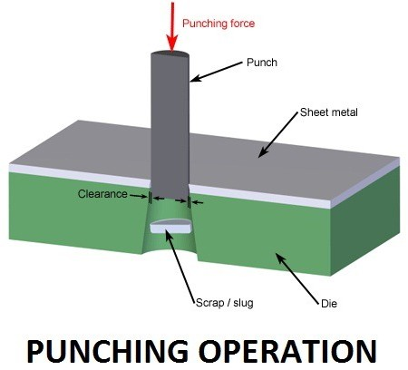

A scrap slug from the hole is deposited into the die in the process. Depending on the material being punched this slug may be recycled and reused or discarded. Punching is ofen the cheapest method for creating holes in sheet materials in medium to high production volumes. When a specially shaped punch is used to create multiple usable parts from a sheet of material the process is known as blanking. In metal forging applications the work is ofen punched while hot, and this is called hot punching. Slugging is the operation of punching in which punch is stopped as soon as the metal fracture is complete and metal is not removed but held in hole

1. Blanking:

Blanking and piercing are shearing processes in which a punch and die are used to

modify webs. The tooling and processes are the same between the Blanking versus piercing two, only the terminology is diferent: in blanking the punched out piece is used and called a blank; in piercing the punched out piece is scrap. The process for parts manufactured simultaneously with both techniques is ofen termed "pierce and blank." An alternative name of piercing is punching.

1. Notching

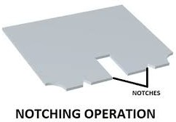This is process of removing metal to the desired shape from side or edge. Notching is a metal-cutting process used on sheet metal or thin barstock, sometimes on angle sections or tube. A shearing or punching process is used in a press, so as to cut vertically down perpendicular to the surface, working from the edge of a workpiece. Sometimes the goal is merely the notch itself, but usually this is a precursor to some other process: such as bending a corner in sheet or joining two tubes at a tee joint, notching one to ft closely to the other.

Notching is a low-cost process, particularly for its low tooling costs with a small range of standard punches. The capital cost of the punch press can be expensive though, so small fabrication shops ofen out-source their notching work to a press shop or notching specialist. Notching of large or heavy sections, particularly for large tube fabrication is increasingly carried out by plasma cutting rather than punch tools. The accuracy of punch notching is good, depending on the care with which it's carried out. For manual folding work, prior notching can ofen improve resultant accuracy of the folding itself. The speed of notching is usually limited by manual handling when loading the workpieces into the press. Pieces some feet long may be manually loaded into a single-stroke press. Almost any workable metal can be notched. It's particularly suitable where the metal is otherwise awkward to drill, such as stainless steels.

1. Lancing

This makes a cut part way across a strip. Lancing is a piercing operation in which the workpiece is sheared and bent with one strike of the die. A key part of this process is that there is not reduction of material, only a modifcation in its geometry. This operation is used to make tabs, vents, and louvers. The cut made in lancing is not a closed cut, like in perforation even though a Process variants similar machine is used, but a side is lef connected to be bent sharply or in more of a rounded manner.

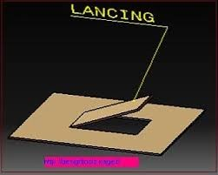

Lancing can be used to make partial contours and free up material for other operations further down the production line. Along with these reasons, lancing is also used to make tabs (where the material is bent at a 90 degree angle to the material), vents (where the bend is around 45 degrees), and louvers (where the piece is rounded or cupped). Lancing also helps to cut or slight shear of sheet on cylindrical shape. Normally lancing is done on a mechanical press, lancing requires the use of punches and dies to be used. The diferent punches and dies determine the shape and angle of the newly made section of the material. The dies and punches are needed to be made of tool steel to withstand the repetitious nature of the procedure.

## B)Bending:

It occurs when forces are applied to localized areas such as, in bending a piece of metal

into right angle. It is a manufacturing process that produces a V-shape, U-shape, or channel shape along a straight axis in ductile A chimney starter, a sample product of bending Press master press brake machine materials, most commonly sheet metal. Commonly used equipment include box and pan brakes, brake presses, and other specialized machine presses.

Typical products that are made like this are boxes such as electrical enclosures and rectangular duct work. In press brake forming, a work piece is positioned over the die block and the d block presses the sheet to form a shape.

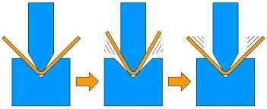

# Fig. V- Bending

Usually bending has to overcome both tensile stresses and compressive stresses. When bending is done, the residual stresses cause the material to spring back towards its original position, so the sheet must be over-bent to achieve the proper bend angle. The amount of spring back is dependent on the material, and the type of forming. When sheet metal is bent, it stretches in length. The bend deduction is the amount the sheet metal will stretch when bent as measured from the outside edges of the bend. The bend radius refers to the inside radius. The formed bend radius is dependent upon the dies used, the material properties, and the material thickness.

## Advantages

Bending is a cost efective process when used for low to medium quantities.

## C)Drawing

It is the operation of producing thin walled hollow or vessel shaped parts from sheet

metal. Drawing is a metalworking process which uses tensile forces to stretch metal or glass. As the metal is drawn The basic drawing process for a wire, bar or tube. (pulled), it stretches thinner, into a desired shape and thickness. Drawing is classifed in two types: sheet metal drawing and wire, bar, and tube drawing. The specifc defnition for sheet metal drawing is that it involves plastic deformation over a curved axis. For wire, bar, and tube drawing the starting stock is drawn through a die to reduce its diameter and increase its length.

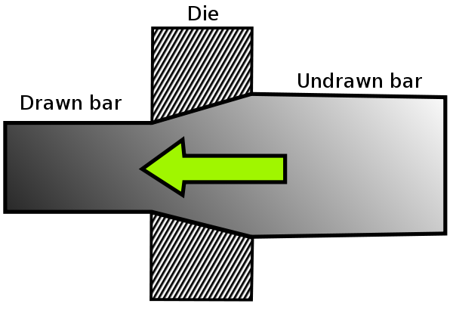

Drawing is usually done at room temperature, thus classifed a cold working process, however it may be performed at elevated temperatures to hot work large wires, rods or hollow sections in order to reduce forces. Drawing difers from rolling in that the pressure of drawing is not transmitted through the turning action of the mill but instead depends on force applied locally near the area of compression. This means the amount of possible drawing force is limited by the tensile strength of the material, a fact that is particularly evident when drawing thin wires.

# MISSION STATEMENT

* + Use of pneumatically controled sheet metal cutter in efficient way
  + Fabrication of pneumatic sheet metal machine with miimum cost as well as possible
  + Making machine automatic and user friendly so that it willl be easier for operations
  + Finally gain experience through individual and team performance

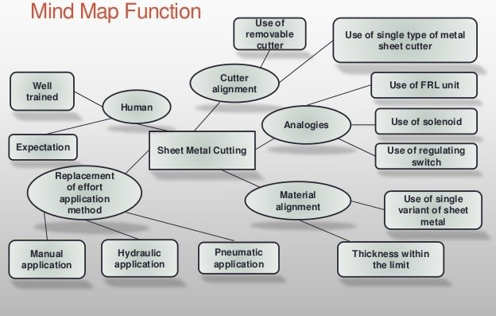

# LITERATURE SURVEY

In shearing or cutting operations aa or blade descends upon the metal. The pressure exerted by the blade first causes the plastic deformation of the metal. Since the clearance between the two blades is very small, the plastic deformation takes place in a localized area and the metal adjacement to the cutting edges of the blade edges becomes highly stressed, which causes the fracture to start on both sides of the sheet as the deformation progress and the sheet is sheared. Shearing machines are classified according to the following:

## Pneumatically Operated

1. **Hydraulically Operated**
2. **Rack and Pinion Operated**
3. **Spring Operated**

Basic information of all the types are as follows -

## Pneumatically Operated

Here the adjacement of the header is carried out in upward and the downward direction using the pneumatic double acting piston and cylinder unit arrangement along with the foot operated direction control valve. In this type of machine, high pressure air is used as the working fluid for the transfer of power and the motion.

## Hydraulically operated

Here the lowering and rising of the header is carried over using the hydraulic piston and cylinder arrangement. To actuate the piston and the cylinder, oil is allowed to enter the cylinder from front or the back side of the piston. But the oil is compositely costlier and its leakage may cause so many problems.

## 08

1. **Rack and Pinion Operated**

Here the lowering and rising of the header is carried out manually using the rack and pinion arrangement. In this case, the required pressure is applied manually using direct hand pressure on the rack using pinion and lever arrangement. Since the machine is robust and requires large pressure, hence it is not suitable.

## Spring Operated

The working of spring operated machine is similar to the rack and pinion operated machine but differs from it in construction. Here the lowering and rising of the heating handle is carried out manually and it requires too much pressure for its operation and also there is possibility of having damage to the workpiece if not handled carefully.

Sheet metal is metal formed by an industrial process into thin, flat pieces. Sheet metal is one of the fundamental forms used in metalworking and it can be cut and bent into a variety of shapes. Countless everyday objects are fabricated from sheet metal. Thicknesses can vary significantly; extremely thin sheets are considered foil or leaf, and pieces thicker than 6mm (0.25in) are considered plate. Microscopic close-up of mild steel sheet metal. Sheet metal is available in flat pieces or coiled strips. The coils are formed by running a continuous sheet of metal through a roll slitter.

In most of the world, sheet metal thickness is consistently specified in millimeters. In the US, the thickness of sheet metal is commonly specified by a traditional, non-linear measure known as its gauge. The larger the gauge number, the thinner the metal. Commonly used steel sheet metal ranges from 30 gauge to about 7 gauge. Gauge differs between ferrous (iron based) metals and nonferrous metals such as aluminum or copper; copper thickness, for example is measured in ounces, which represents the weight of copper contained in an area of one square foot. Parts manufactured from sheet metal must maintain a uniform thickness for ideal results.

# 09

There are many different metals that can be made into sheet metal, such as aluminium, brass, copper, steel, tin, nickel and titanium.

## Stainless steel

* + Grade 304 is the most common of the three grades. It offers good corrosion resistance while maintaining formability and weldability.
  + Grade 316 possesses more corrosion resistance and strength at elevated temperatures than 304. It is commonly used for pumps, valves, chemical Materials equipment, and marine applications.
  + Grade 410 is a heat treatable stainless steel, but it has a lower corrosion resistance than the other grades. It is commonly used in cutlery.
  + Grade 430 is popular grade, low cost alternative to series 300's grades. This is used when high corrosion resistance is not a primary criteria. Common grade for appliance products, often with a brushed finish.

## Aluminium

Aluminum is also a popular metal used in sheet metal due to its flexibility, wide range of options, cost effectiveness, and other properties. The four most common aluminium processing equipment, light reflectors, and jewelry.

* + Grade 3003-H14 is stronger than 1100, while maintaining the same formability and low cost. It is corrosion resistant and weldable. It is often used in stampings, spun and drawn parts, mail boxes, cabinets, tanks, and fan blades.
  + Grade 5052-H32 is much stronger than 3003 while still maintaining good formability. It maintains high corrosion resistance and weldability. Common applications include electronic chassis, tanks, and pressure vessels.

# 10

* + Grade 6061-T6 is a common heat-treated structural aluminium alloy. It is weldable, corrosion resistant, and stronger than 5052, but not as formable. It loses some of its strength when welded.

## Brass

In sheet hydroforming, variation in incoming sheet coil properties is a common problem for forming process, especially with materials for automotive applications. Even though incoming sheet coil may meet tensile test specifications, high rejection rate is often observed in production due to inconsistent material behavior. Thus there is a strong need for a discriminating method for testing incoming sheet material formability.The hydraulic sheet bulge test emulates biaxial deformation conditions commonly seen in production operations.

Here an attempt is made to review the status of literature in pneumatic based on various criteria. The work done by various authors are explained below.

**Vallance and Matlock (1992)** studied the friction behavior of zinc-based coated sheet steels and laboratory scale friction analysis techniques that involve sheet sliding over cylindrical dies.

**Mai Huang and Gardeen (1994**) presented a literature review of the springback of doubly curved developable sheet metal surfaces and provided a bibliography on the springback in sheet metal forming. Reviewing the literature, it is found that researchers have been studying the phenomenon of springback for nearly six decades. There have been diverse efforts to evaluate and/or decrease springback in the sheet metal forming industry for a long time.

**Perduijn and Hoogenboom (1995)** derived a simple explicit bending couple curvature relation for small and larger curvatures and they verified the model with experimental results.

**Sanchez (1999)** focused on a systematic analysis of testing equipment as a measurement system of the friction phenomena on sheet metal under plane strain. It provides experimental references in order to optimize the usage of lubricants and sheet metal.

**Samuel (2000)** analyzed the springback in axisymmetric Ubending processes with a finite element program and discussed the effect of tool geometry and blank holder force on the final shape after springback.

**Aleksy et al (2001)** conducted experiments on springback for dual phase steel and conventional high strength steel for a hat channel section with varying cross sections. They described the methodology of experiments and discussed springback related results.

**Carlos Gomes et al (2005)** investigated the variation of springback in high strength steels based on experimental and numerical analysis.

**Se Young kim et al (2007)** examined the effect of tool design and process parameters on the springback of GLARE and the parameters studied include punch radius, punch speed, forming load and forming temperature.

# NEED FOR AUTOMATION

Automation can be achieved through computers, hydraulics, pneumatics, robotics etc. Of these sources, pneumatics form an attractive medium for low cost automation. The main advantages of all pneumatic systems are economy and simplicity. Automation plays an important role in the mass production.

* Reduction of material cost
* Reduction of overall cost
* Increased production
* Increased safety for labour
* Improved personnel comfort
* Easy operation

# SPECIFICATION OF PNEUMATIC ELEMENTS

The various pneumatic elements are specified according to different standards. The standard varies depending upon the manufacturers.

|  |  |  |
| --- | --- | --- |
| **1. Double acting Cylinder**  Stroke length | = | 125 mm |
| piston diameter | = | 32 mm |
| maximum operating pressure | = | 8-10 bar |
| Material | : | Plain Carbon Steel |
| Seals | : | Acrylo-nitrile Butadine Rubber |
| **2. Direction Control Valve**  Maximum operating pressure | = | 8 bar |
| Port Size | = | 1/8 |
| Media | : | Air |

# MAIN COMPONENTS

The major components of these syetems are'

* + Compressor
  + FRL Unit
  + Pneumatic Double Acting Cylinder
  + Direction Control Valve
  + Housing and Fittings
  + Frame
  + Cutting Blades

# COMPRESSOR

The air under high pressure is given by a compressor. It is driven by an electric motor. The compressor delivers air to inlet of the cylinder. An air compressor as the same indicates is a machine to compress the air and to raise its pressure. The air compressor sucks air from the atmosphere, compressor it and then delivers the same under a high pressure to a storage vessel from the storage

An air compressor is a device that converts power (using an electric motor, Air compressor supplies air into a nail gun diesel or gasoline engine, etc.) into potential energy stored in pressurized air (i.e., compressed air). By one of several methods, an air compressor forces more and more air into a storage tank, increasing the pressure. When tank pressure reaches its engineered upper limit the air compressor shuts off. The compressed air, then, is held in the tank until called into use.

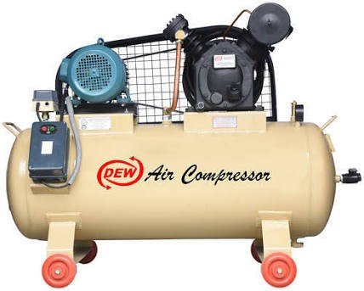

The energy contained in the compressed air can be used for a variety of applications, utilizing the kinetic energy of the air as it is released and the tank depressurizes. When tank pressure reaches its lower limit, the air compressor turns on again and repressurizes the tank. An air compressor must be differentiated from an air pump which merely pumps air from one context (often the surrounding environment) into another (such as an inflatable mattress, an aquarium, etc.). Air pumps do not contain an air tank for storing pressurized air and are generally much slower, quieter, and less expensive to own and operate than an air compressor.

Compressors can be classified according to the pressure delivered:

1. Low-pressure air compressors (LPACs)
2. Medium-pressure compressors (MPACs)
3. High-pressure air compressors (HPACs)

They can also be classified according to the design and principle of operation:

1. Single-Stage Reciprocating Compressor
2. Two-Stage Reciprocating Compressor
3. Compound Compressor
4. Rotary-screw compressor
5. Rotary Vane Compressor
6. Scroll Compressor
7. Turbo compressor
8. Axial Compressor

**17**

# PNEUMATIC CYLINDERS

Cylinders are the most important means of actuation in pneumatics. The cylinder transfers the energy that is stored in the compressed air into movement.

They can be classified by:

## Design

* + Cylinders with piston rods
  + Rodless cylinders
  + Diaphragm cylinders
  + Rotary cylinders

## Movement

* + Linear
  + Rotary

## Function

* + Single-acting
  + Double-acting
  + 3 or 4 positions

## Cushioning

* + Adjustable, pneumatic cushioning
  + Flexible cushioning
  + Without cushioning

# DOUBLE ACTING CYLINDERS

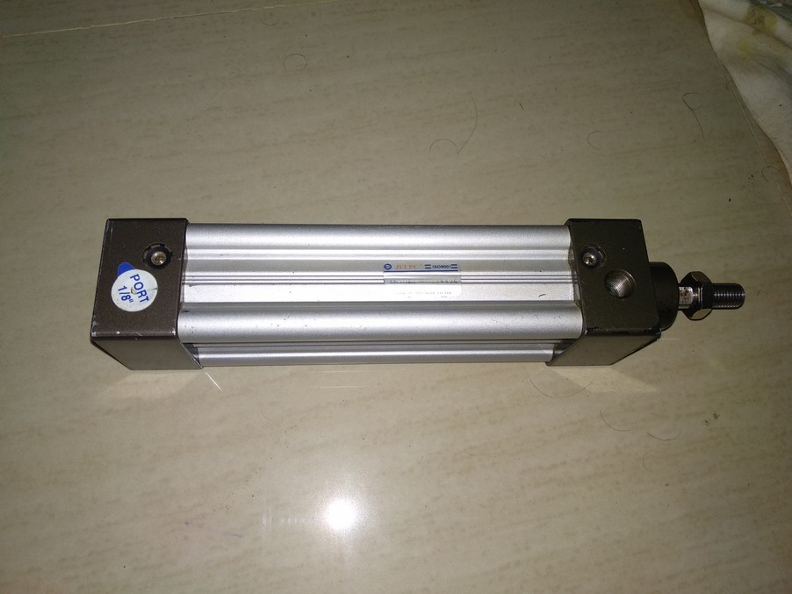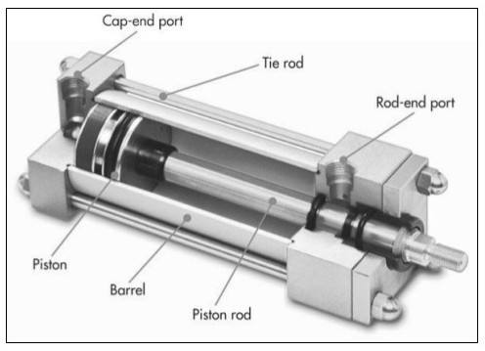

## Model : JLPC ISO 9001

Schematic diagram of double acting cylinder is shown below. Double Acting Cylinders are equipped with two working ports one on the piston side and the other on the rod side. To achieve forward motion of the cylinder, compressed air is admitted on the piston side and the rod side is connected to exhaust. During return motion supply air admitted at the rod side while the piston side volume is connected to the exhaust. Force is exerted by the piston both during forward and return motion of cylinder.

# VALVES

Valves are defined as devices to control or regulate the commencement, termination and direction and also the pressure or rate of flow of a fluid under pressure which is delivered by a compressor or vacuum pump or is stored in a vessel.

Valve available for pneumatic control can be classified into four principal groups according to their function:

* Direction control valve
* Non return valves
* Flow control valves
* Pressure control valves

# DIRECTION CONTROL VALVES

Pneumatic systems like hydraulic system also require control valves to direct and regulate the flow of fluid from the compressor to the various devices like air actuators and air motors. In order to control the movement of air actuators, compressed air has to be regulated, controlled and reversed with a predetermined sequence. Pressure and flow rates of the compressed air to be controlled to obtain the desired level of force and speed of air actuators. The function of directional control valve is to control the direction of flow in the pneumatic circuit. DCVs are used to start, stop and regulate the direction of air flow and to help in the distribution of air in the required line.

## TYPES OF DIRECTION CONTROL VALVE

Directional valves control the way the air passes and are used principally for controlling commencement, termination and direction of air flow. The different classification scheme of the pneumatic cylinders are given below

## 20

**Based on the Number of ports**

* Two way valves
* Three way valves
* Four way valves

## Based on methods of actuation

* Mechanical
* Electrical
* Pneumatic

# Hand Lever Operated 5/2 D.C. Valve

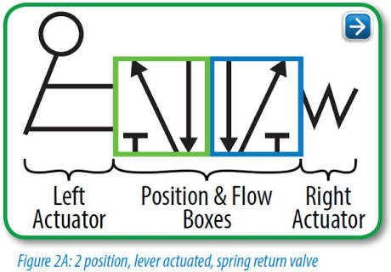

**FRL Unit**

It is imperative that a filter, regulator, lubricator (FRL) be employed when running pneumatic tools. The air should be clean, dry, and lubricated to maximize life and performance of the pneumatic tool. If the air filter bowl contains water, drain the bowl by pressing and holding the small button on the bottom of the bowl until the water is completely drained. Observe the maximum water level line on the metal protective shield of the bowl. Water can be drained with either the air supply on or off. The oil level in the air lubricator must be maintained for proper lubrication of the pneumatic tool. The minimum and maximum oil levels are indicated on the metal protective shield of the oiler bowl. To add oil, remove the black oil plug at the top of the oiler with a ¼” hex wrench, add oil and replace the plug. USE NONFLUID OIL.

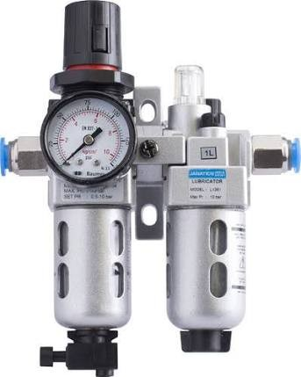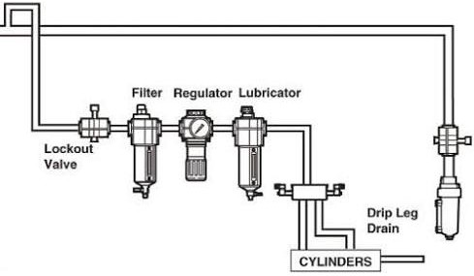

Fig. FRL unit Fig. Line Diagram Of FRL Unit

Oil can be added with either the air supply on or off. The air pressure is indicated on the dial gauge on the front of the Pressure Regulator. To adjust the air pressures, pull the large black knob below the gauge down to the unlocked position. When unlocked, an orange band can be observed on the top of the knob (Figure 1). Turn the knob clockwise to increase the pressure. When the desired pressure is reach push the knob up to the locked position. (The orange band is no longer visible.)

The amount of lubricant supplied to the pneumatic tool is regulated by the number of drops of oil per minute and is observed through the site window of the oil adjusting valve knob at the top of the . Air Lubricator (Figure 1). Check the specific pneumatic tool manual for lubrication requirements. Numbers on the scale of the adjusting knob do not indicate drop amounts. Turn the adjusting knob clockwise to the off position then turn that same knob counter clockwise until the indication mark is on 4 or 5. This is a good starting point. The tool must be running to adjust the number of drops per minute of lubricant. With the pneumatic tool running, turn the knob to adjust to the required number of drops. Counterclockwise will increase the number of drops.

# SHEARING BLADES

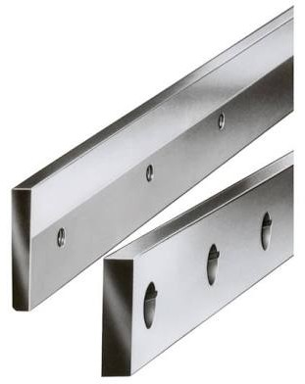Cutting operations involve the separation of the metals of the sheet in certain areas. This separation is caused by shearing forces acting on the meta through the edges of the punch and die. The cutting process is done by applying shear force. Due to application of shear force the stress in the material will exceed the ultimate shear strength and material will fail .

Fig. Shearing Blades

Shearing force is applied by the two blades one above and one below sheet. The upper blade delivers quick downward blow to sheet metal that rests on lower blade. The upper tool penetrates on the sheet causing shearing and material failure.

The factors affecting the cut with plate shears are in the main cutting plane.& plane perpendicular to it, The clearance (u), cutting angle (α), angle of skew (γ) and angle of tilt (β) affect the cut. If the cutting angle (α) is zero, the cutting process is called blanking. This means that the upper and lower blades are parallel, and the entire width of the plate is cut at the same time. When the cutting angle is other than zero, the process is called guillotining. This is the most common and important process with straight-blade cutters.

Rotary shearing is very similar to guillotine shearing as far as cutting geometry is concerned, and they are often considered to be equal processes. Clearance (u) is the distance between the upper and lower blades. The clearance in cutting machinery can usually be adjusted within certain limits. In guillotine shears only the horizontal clearance between the blades is adjusted. In rotary shears, both the horizontal and vertical clearance (h) is adjustable.

The adjustment of the vertical clearance affects especially on the separation of the cut strip. You can also affect the cutting result through the angle of tilt (β) and angle of skew (γ) values. When cutting narrow strips, the correct angle of tilt reduces cutting faults and at the same time slightly reduces the wear of the blades. Setting the angle of skew value between 1 and 2 degrees results in a straight, rectangular cut. With this setting, the clearance does not remain constant, but grows as the cutting proceeds.

## POLYURETHENE TUBE

A pipe is a tubular section or hollow cylinder, usually but not necessarily of circular cross-section, used mainly to convey substances which can flow liquids and gases (fluids), slurries, powders, masses of small solids. It can also be used for structural applications; hollow pipe is far stiffer per unit weight than solid members. In common usage the words pipe and tube are usually interchangeable, but in industry and engineering, the terms are uniquely defined. Depending on the applicable standard to which it is manufactured, pipe is generally specified by a nominal diameter with a constant outside diameter (OD) and a schedule that defines the thickness. Tube is most often specified by the OD and wall thickness, but may be specified by any two of OD, inside diameter (ID), and wall thickness.

# ADVANTAGES

* The pneumatic is more efficient in the technical field.
* Quick response is achieved.
* Easy maintenance and repair.
* Low investing cost.
* Continuous operation is possible without stopping.
* Compact size and less floor space is used.
* All movements are pneumatically operated.
* Optional solution of operation is Electrical control panel.
* Ragged construction to suit in highly acidic atmosphere & high temperature.
* All pneumatic actuators are S.S. to suit corrosive atmosphere.
* Air is available everywhere Can be stored easily
* Clean and non – pollutant
* Transportable over long distances
* High speed operation
* Relatively low cost to produce
* Technology can be easily learned

# APPLICATIONS

* For Paper cutting
* For sheet cutting
* For stamping operating

# FABRICATION OF MACHINE

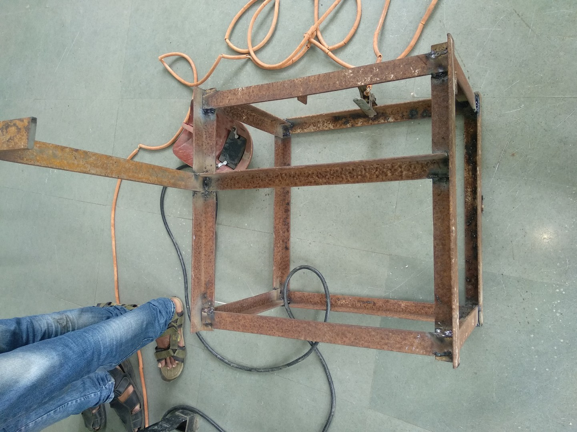

Fig. Frame

To mount the double acting cylinder frame is used which is shown in fig. Material used to construct this frame is Mild Steel. First of all a straight andgle plate of MS is cut into pieces which are welded according to the dimensions. Now, arrangement for fixing of cylinder is made. Cylinder is fitted to the horizontal plate which at top of the frame.

Since cylinder is having four holes, thus to the top plate four drill are made. Cylinder is fitted using this drills. Depending upon the stroke of cylinder, position of shearing blades is decided.

Shearing blades are fixed in such a way that one blade is fixed on frame and other one is attached to piston rod. To transfer reciprocating motion of piston rod into curviliear motion of upper shearing blade, we have used riveted joint, so that it permits blade to move in curvilinear motion.

# MACHINE AND TOOLS USED

Cutting Machine Hand Grinder Table grinder

Surface grinding machine Hack saw cutter

Driling machine Welding machine Lathe machine

# SPECIFICATIONS

## Base Frame

Quantity : 1

Height : 40 cm

Length : 57.5 cm

width : 56 cm

## Shearing Blades

Quantity : 2

Length : 38 cm

Height : 5.5 cm

Width : 0.5 cm

Blade Angle: : 30'

## Angle Section

Quantity : 1

Height : 50 cm

Length : 40 cm

Width : 5cm

## Following are various operation performed for construction of frame :

1. **CUTTING**

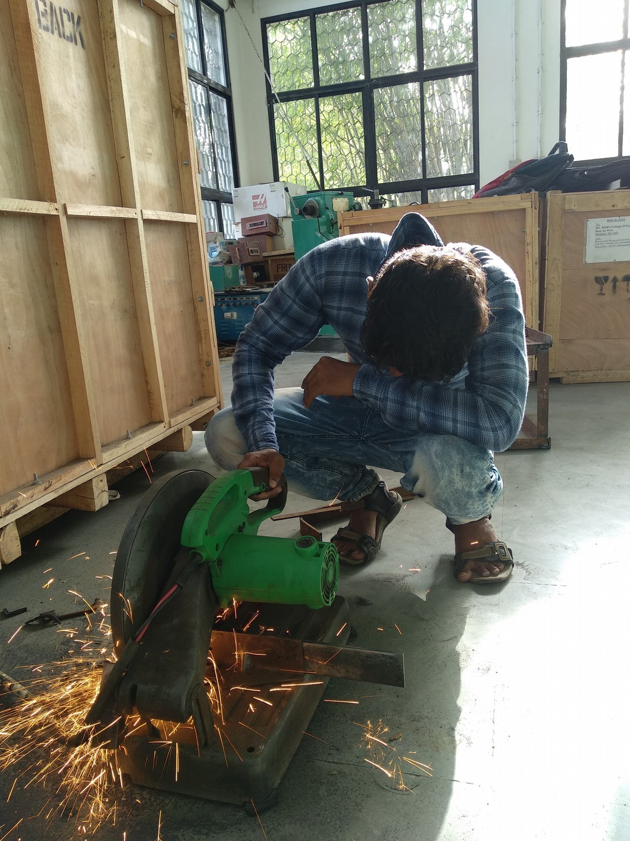

1. **WELDING**

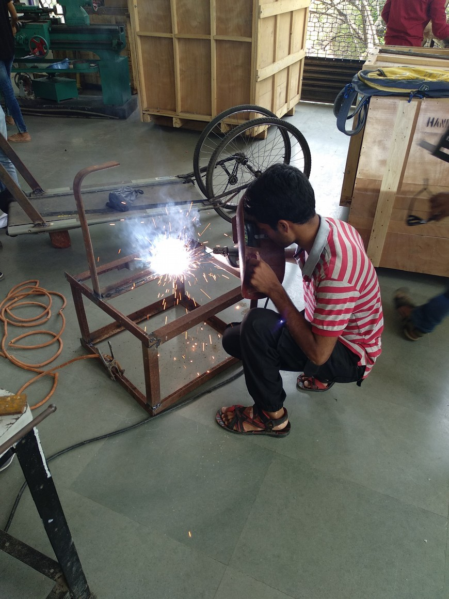

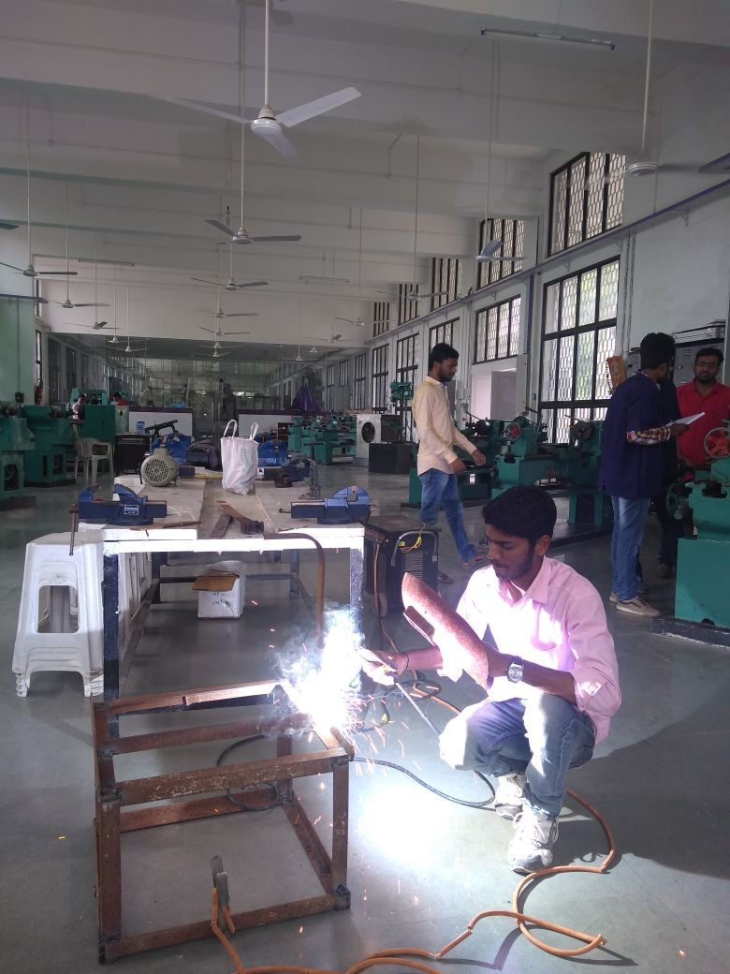

1. **TURNING OPERATION ON LATHE FOR SCREW**

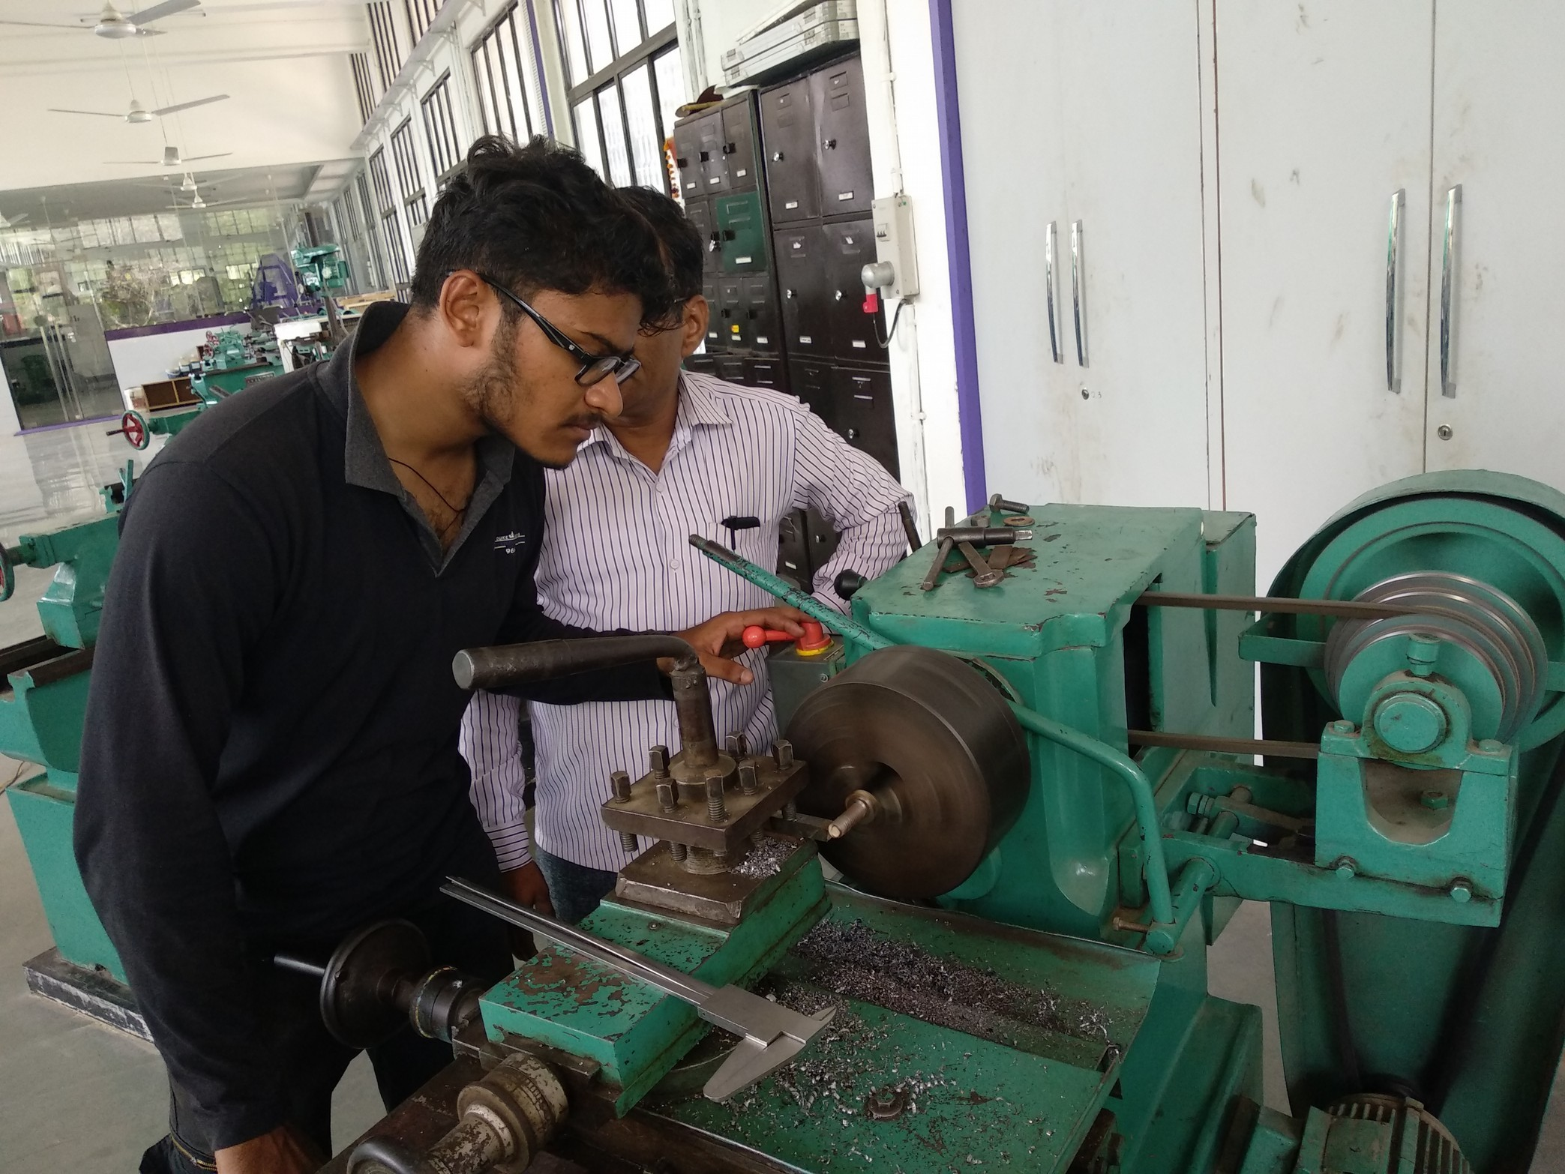

1. **SURFACE FINISHING OF BLADES**

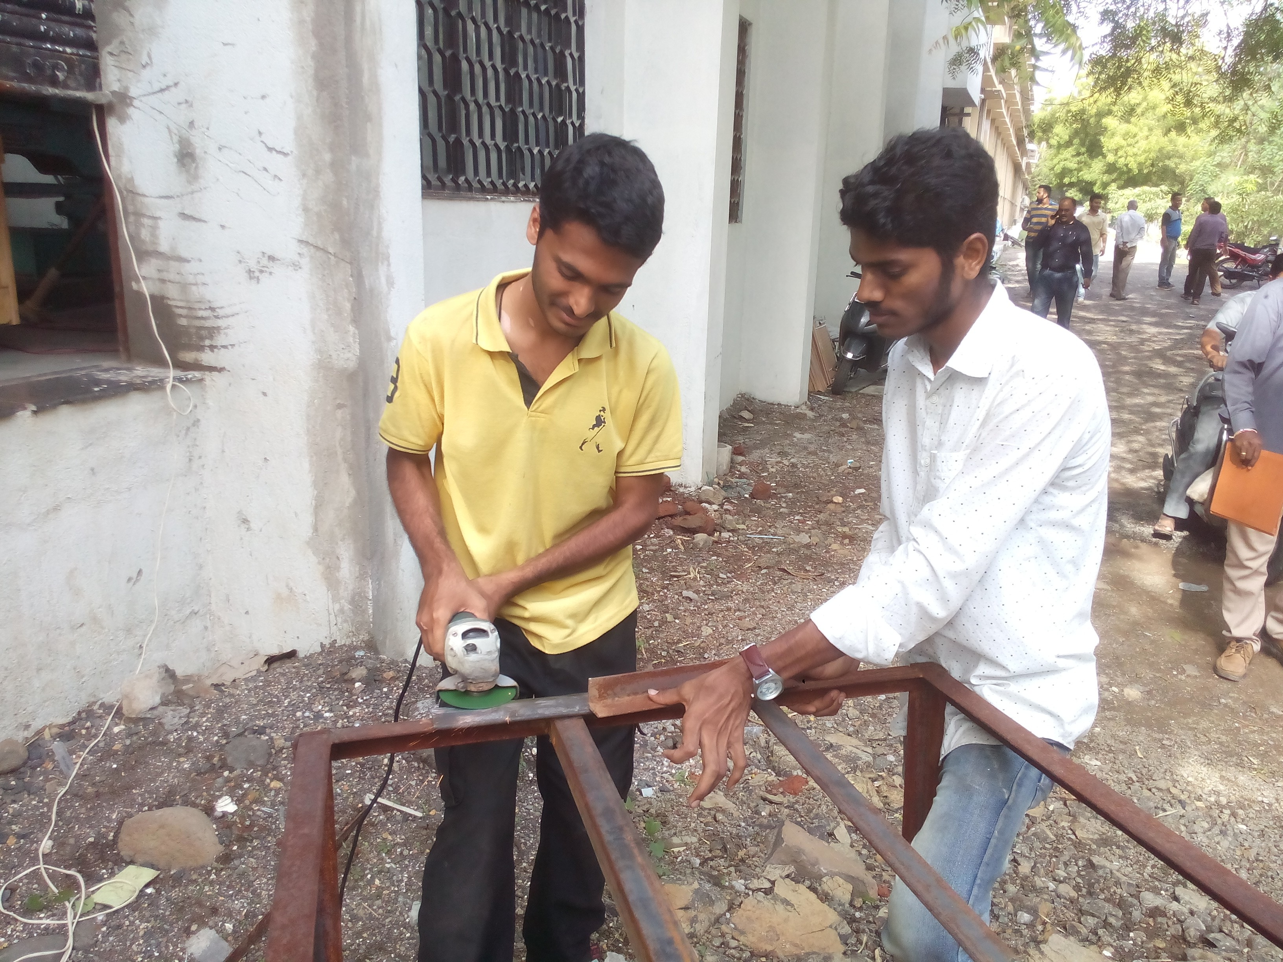

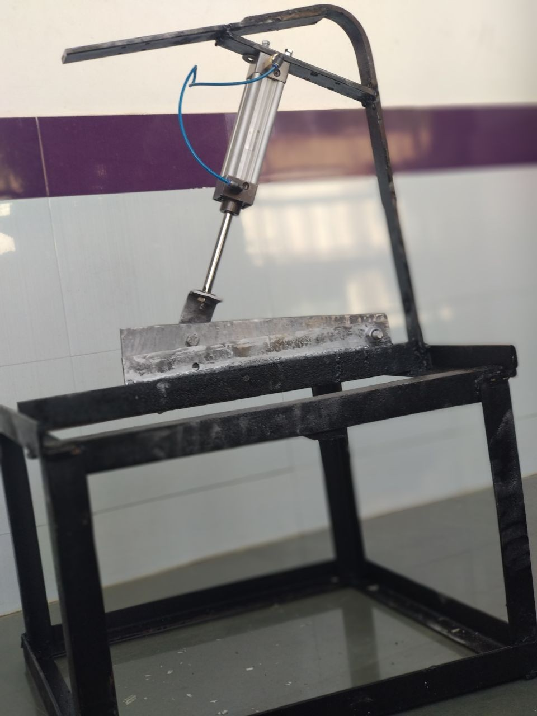**34**

**Fig. Fabricated Machine**

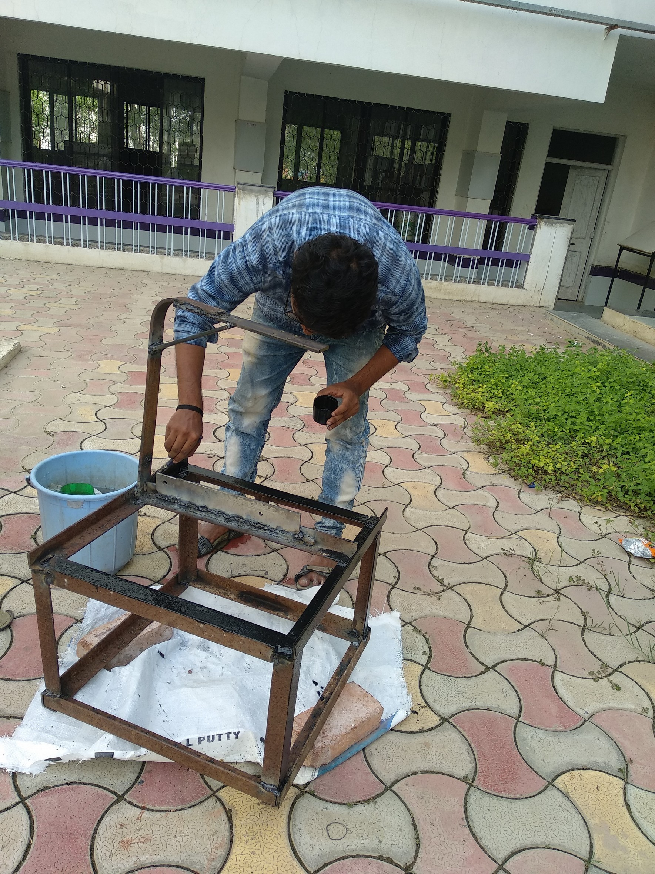

**Fig. Painting The Frame**

**WORKING**

The pneumatic machine includes a table with support arms to hold the sheet, stops or guides to secure the sheet, upper and lower straight edge blades, a gauging device to precisely position the sheet. The table also includes the two way d.c. valve. The two way directional valve is connected to the compressor.

The compressor has a piston for a movable member, the piston is connected to a crankshaf which is in turn connected to a prime mover(electric motor i.c. engine). At inlet and outlet ports, valves allow air to enter and exit the chamber. When the compressor is switched ON, the compressed air fows to inlet of the pneumatic cylinder. The sheet is placed between upper and lower blades. The lower blade remains stationary while upper blade is forced downward.

The upper blade is slightly ofset from lower blade, approximately 5-10% of sheet thickness. Upper blade is angled so that the cut progresses from one end to other, reducing required force. When pneumatic hand operated lever is moved forward, the piston starts moving in forward direction. When pneumatic hand operated lever is moved backward, upper blade will come to its original position. Afer material is cut, adjust the pneumatic hand lever to mid position and then then compressor is switched OFF.

# COST ESTIMATION

|  |  |  |  |  |
| --- | --- | --- | --- | --- |
| Sr. No. | Part Name | Quantity | Material | Material Cost |

## Base Frame

|  |  |  |  |  |
| --- | --- | --- | --- | --- |
| 01 | Main Frame | 01 | Mild Steel | 1200 |
| 02 | Angle Plate | 01 | Mild Steel | 100 |
| 03 | Cylinder Base Plate | 01 | Mild Steel | 30 |

* 1. **Pneumatic Circuit Components**

|  |  |  |  |  |
| --- | --- | --- | --- | --- |
| 04 | Double Acting Cylinder | 01 | Plain Carbon Steel | 2500 |
| 05 | Slide Valve | 01 | Alloy Steel | - |
| 06 | Pipe | 04 | PVC | - |
| 07 | D.C. Valve | 01 | Alloy Steel | - |

* 1. **Others**

|  |  |  |  |  |
| --- | --- | --- | --- | --- |
| 08 | Bolts | 06 | Alloy Steel | 30 |
| 09 | Nuts | 06 | Alloy Steel | 30 |
| 10 | Paints | 200mL | - | 100 |
| 11 | Shearing Blades | 02 | Carbon Steel | 700 |

**CONCLUSION**

This project work has provided us an excellent opportunity and experience to use our limited knowledge. We gained a lot of practical knowledge regarding, planning, designing, drawing, purchasing, computing and machining using various machines like hand grinding m/c, cutting m/c, drilling m/c, welding m/c, lathe m/c etc. We feel that project work is a good solution to bridge the gates between institution & industries.

We feel proud that the project has completed upto date successfully. The m/c is working with satisfactory results. We can understand those difficulties which occur in maintaining the tolerances and quality. We have done to prove our ability upto the best level.

The chief advantage of our system is that the cutting speed is flexible as per the sheet.

Fast operation is done by the timer unit which is a low cost project.

# FUTURE SCOPE

Since old man is always trying to gain more and more luxurious. Man is always trying to develop more and more modified technique with increasing the aesthetic look and economic consideration. Hence there is always more and more scope. But being the degree Engineers and having the ability to think and plan. But due to some time constraints, and also due to lack of funds we only have thought and put in the report the folloting furute modifications.

1. It can be made hydraulic operated type by replacing the hand lever by hydraulic cylinder along with the natchet and paul arrangement.
2. It can be made hydraulically power operated by installing the gear oil pump at the place of air compressor and pneumatic cylinder arrangement.
3. It can be made rack and pinion operated or spring and lever operated by replacing the pneumatic circuit by rack and pinion arrangement by the square threaded screw and nut arrangement.
4. The stationary platform can be made auto swiveling type by installing the timer and heat sensor arrangement on the platform. It can be done such that when the bottle mouth is sealed up to the desired temperature the electrical heater circuit gets cut off. At the same time the motor installed on the reduction gear box starts operating the bevel gearing and the platform starts rotating thus it can be made auto rotating type.

# REFERENCES

* Machine design by R. S. Khurmi.
* Manufacturing process by O. P. Khanna and Lal.
* Workshop technology by R. k. Jain.
* Hydraulic and pneumatic system written by srinivasan.
* P. S.G. Design Handbook.

# RESEARCH PAPER 1

## PNEUMATIC SHEET CUTTING MACHINE- A REVIEW

Neeraj Pandita , Naren Kesar, Akshit Jasrotia , Surya Dev Singh ,

Lakshay Jolly , Anant Khajuria , Vishwarth Singh IJ

Faculty of Mechanical Engineering, Yogananda College of Engineering and Technology, Patoli, Jammu, (J&K), 181205 - India

Department of Mechanical Engineering, Yogananda College of Engineering & Technology, Patoli, Jammu, (J&K), 181205 - India

## ABSTRACT-

This is an industrial era and in order to have better surface finish and obtain a high degree of flexibility in the manufacturing processes in the industries, a lot of work is done on sheet metal. To ensure the adequate demand, sheet metal is cut and bent into variety of shapes. This is a review of the previous work done on the sheet metal where the cutting and bending of the sheets has been studied under various conditions. The pneumatic sheet cutting machines are one of the modern techniques which are used efficiently to make the sheet cutting and bending an efficient process. This work reviews the reliability, performance and the possibilities of simplifying the design of the pneumatic sheet cutting machines. The present work also reviews the energy lost in the pneumatic cylinder while it is made to impart the force on the cutting blade. The energy efficiency of pneumatic and compressed air systems is an important element in the overall development of sustainable production. The objective of this cross-discipline review is to update production and life cycle engineering researchers on state of art in energy efficiency for pneumatic production and associated compressed air infrastructure.

**Keywords -** Efficiency, manufacturing, Pneumatic sheet cutting machine etc

Sheet metal industries use the sheet cutting machine, as these are used to carry out most of the operations in the sheet metal industry. The sheet cutting machines require human effort to cut down the sheets but it can be replaced by the pneumatic cutting machine. A pneumatic cutting machine is a pneumatically powered sheet cutting machine which can cut the sheets at a faster and convenient way. It also reduces the effort required during handling the cutting. In sheet cutting operation, the pressure exerted by the punch causes the plastic deformation of the metal. There is very small clearance between the punch and the die where the plastic deformation takes place.

Pneumatic system is used for the automation of machine and to solve industrial labour problems. Sheet metals have a variety of applications in making car bodies, roofs for buildings, medical tables etc. Now a day’s sheet metal is also used in making furniture and cupboard . separated by applying enough force to cause the material to fail. The most common process is shearing process as in this the cutting processes are performed by applying shearing force. The shear stress in the material will exceed the ultimate shearing strength when a greater shearing force is applied and the material will fail and separate at the cut location. This shearing force is applied by two tools, one above and one below the sheet. These tools can be upper and lower blades or a punch and die. The tool above the sheet delivers a quick downward blow with certain force to the sheet metal that rests over the lower tool. A very small clearance is present between the blades i.e. edges of the upper and lower tools, which facilitates the fracture in the sheet metal. An attempt has been made to review the literature in pneumatic systems in sheet cutting, based on various criteria. Pneumatic is a branch of engineering that makes use of pressurized air or gas.

Pneumatic systems are used extensively in industries and are mostly powered by compressed gases or compressed air. An electrically powered and centrally located compressor powers air motors, cylinders and other pneumatic devices. A pneumatic system can be either controlled through manual or automatic solenoid valves which are selected because they provide low cost, more flexibility and safer alternative to electric motors and actuators. Pneumatic systems also have applications in mining, dentistry, construction, and other areas

These tools can be upper and lower blades or a punch and die. The tool above the sheet delivers a quick downward blow with certain force to the sheet metal that rests over the lower tool. A very small clearance is present between the blades i.e. edges of the upper and lower tools, which facilitates the fracture in the sheet metal. An attempt has been made to review the literature in pneumatic systems in sheet cutting, based on various criteria. Pneumatic is a branch of engineering that makes use of pressurized air or gas. Pneumatic systems are used extensively in industries and are mostly powered by compressed gases or compressed air. An electrically powered and centrally located compressor powers air motors, cylinders and other pneumatic devices. A pneumatic system can be either controlled through manual or automatic solenoid valves which are selected because they provide low cost, more flexibility and safer alternative to electric motors and actuators. Pneumatic systems also have applications in mining, dentistry, construction, and other areas.

A lot of authors and researchers have worked on pneumatic systems as well as on sheet metal experiments. The work done by various authors are explained below

**Perduijn et al** in their research, reported a simple explicit bending couple curvature relation for small and larger curvatures and they have also verified and stated their experimental results.

**Sanchez et al** has focused on a systematic analysis of testing equipment as a measurement system of the friction phenomenon on sheet metal under plane strain. It has also provided experimental references in order to optimize the usage of sheet metal and lubricants.

**Mutoh et al** Energy consumption of pneumatic system results into losses. They also proposed that the exhaust pressure of the cylinder hold middle level 0.2 - 0.5 MPa. If exhaust flow is used effectively, losses can be reduced in pneumatic systems. They reported if exhaust pressure is set near 0.2 MPa, it reduces the losses by 15% of total consumption.

# COMPONENT USED

## PNEUMATIC CYLINDER

These are the devices which produce a reciprocating linear motion by making use of power from compressed gas. The working fluid used in pneumatic cylinders is compressed air. The pneumatic cylinder is a mechanical device and the compressed air is converted into kinetic energy. Pneumatic cylinders can produce large amount of force by making use of different ranges of velocities. They work at high speeds and run continuously without getting overheated or any internal damage. They come in different sizes and configurations. A hole is provided at one end of the cylinder of piston rod in order to connect it to the mechanism. It is fitted with a gland In order to ensure prevention of leakage of working fluid.

## DIRECTION CONTROL VALVE

The direction of air flow can be controlled in the pneumatic system by making use of direction valve. It is also called as DCV. It consists of a solenoid which is used for the conversion of electrical energy into straight line motion as well as force. It can be of two types i.e. pushing type of pull type. A plunger is pushed in push type solenoid where as in pull type; plunger is energized when the plunger is pulled inwards. A cylinder is fitted with a spool inside it which can be controlled electrically or mechanically. To ease the operation, we have used the electrically controlled DCV. The flow is controlled or redirected by the movement of the spool. In fluidics, solenoid valves are most commonly used as control devices.

## PNEUMATIC COMPRESSOR

These are the devices that are used for the conversion of power into potential energy. This potential energy is stored in the form of compressed air. The pressure of the storage tank is increased by compressing more and more air into it. After this, the compressor shuts off automatically when the upper limit of tank pressure is reached .

The air is also held in it until it is used. The stored energy can be utilized for numerous applications. The air compressor again turns on when pressure in the tank decreases. In our project we are also studying the role of advection of compressed air and the losses associated with it which also leads to the study of convective heat transfer.

## ROTARY SCREW COMPRESSOR

Rotary screw compressor makes use if the positive displacement compression. This is done by correctly arranging the two helical screws so that the volume of the chamber is decreased by turning the screws.

## PVC TUBE

It is used to pass substances which can flow through it. It can be used for various applications. The hollow pipes are generally stiffer than solid pipes. It generally consists of a nominal diameter and schedule that defines the thickness.

## CUTTING BLADE

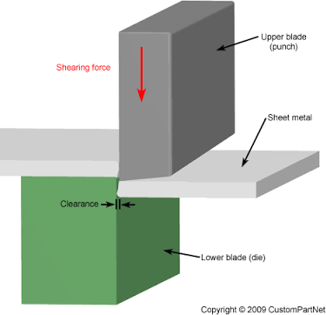It is one of the main components which cut the metallic sheets. Generally it is made of high carbon steel because there is huge resistance in the metallic sheets which are to be sheared. It is used to cut the sheets of metal of varying sizes; generally thickness may vary from 1 mm to 5mm. A compressor of size nearly 8-14 Kg/cm2 is enough to cut down the sheet having thickness up to 5 mm.

# ADVANTAGES

* 1. More effective in cutting process.

1. Simpler in construction
2. Easier maintenance and repair
3. Continuous operation is possible.
4. Cutting without bending is achieved.
5. Compact size and less floor space is used.
6. Human effort is reduced.

# APPLICATIONS

1. Automobiles and aeroplanes
2. Medical tables,
3. Architectural use
4. For Paper cutting
5. For sheet cutting
6. For stamping operating
7. Oil and gas industry

# FUTURE SCOPE

Pneumatic sheet cutting machine is a very versatile machine and has a lot of applications because of it flexibility and ease of doing operations. This machine can be converted into a punching machine by removing the blade and adding punching die to the end of the piston. By increasing the pressure, we can cut more sheets collectively. Because of it enormous use in industries higher production rate can be achieved by balancing the forces and making the design more compact. Software and advance controlling systems can improve the machine’s performance. By replacing the pneumatic circuit with rack and pinion arrangement, it can be converted into rack and pinion operated machine. The electric motor air compressor can also be replaced by an IC engine installed compressor where we are deprived of electric energy. In this machine, the ideal stroke wastes the air which moves out through the out port of control unit. In future, mechanism can be developed to use the air again for the working of cylinder.

# CONCLUSION

This study revealed that the Pneumatic cutting machine is effective as compared to manual sheet cutting and bending approaches. The range of this cutting machine is that it can cut thick sheets by arranging a high pressure compressor. Efficiency of the machine can further be enhanced by suitably selecting the cutting blade material. This machine is advantageous to small sheet metal cutting industries because of its versatility and compactness. The literature survey also revealed that energy losses can be minimised by optimising the pressure in the cylinder. It can also be inferred that by using pneumatic system, minimum losses occur and hence are more reliable.

# RESEARCH PAPER 2

## DESIGN AND FABRICATION OF PNEUMATIC SHEET METAL CUTTING MACHINE-A REVIEW

**Suraj V Bhosale, Gajanan S Ghute, Nikita H Dudhe, Ashish G Ingle**

**Department of Mechanical Engineering, DES’s COET Dhamangaon (Rly.), Amravati University, Maharashtra, India**

**ABSTRACT IJERT**

Normally the sheet metal cutting machine is manually hand operated for medium and small scale industries. This paper gives an insight about the automatic sheet metal cutting machine. Any automatic machine aimed for economical use of man. In this paper, pneumatic cylinder is used for cutting in easy way which can be use in small scale industries at lower cost. The sheet metal cutting machine works with the help of pneumatic double acting cylinder. The piston is connected to the moving cutting tool which is used to cut the sheet metal. The cutting process is operated by a direction control valve by using compressor. In manual method sheet metals goes to the scrap sometime because of wrong dimensions, improper cutting etc. Hydraulic machines are also used for sheet metal cutting. But this machines are used for heavy metal cutting and its cost is very high. Hence, we are using a pneumatic system for sheet metal cutting in a easy manner. The main advantage of pneumatic sheet metal cutting machine is to improve product quality, repetition of work and increasing production rate.

**Key words**- Pneumatic Cylinder, Control Valve, Compressor, Sheet Metal.

## INTRODUCTION

The sheet cutting machine is the heart of sheet metal industries. In some industries, hand sheet cutter is used which is operated manually. In these machine, we are using pneumatic cylinder for sheet metal cutting. These machine should be easy to operate and maintain also. Hence, we are introducing a pneumatic sheet metal cutting machine which will reduce manufacturing cost and minimize industrial labor problems which is the biggest headache for human . The main objective of our project is to perform job holding operation effectively with less human efforts by using a machine with the pneumatic power. This will also reduce the time required for metal cutting. By using these machine we can increase the production rate and automatically the industry will be in profit. Automation plays an important role in mass production. Automation can be achieved through pneumatic form.

The main advantage of pneumatic system is economically cheap and easy to handle. The manufacturing operation is being atomies for the following reasons.

➢ To reduce human efforts

➢ To increase production rate

➢ To increase efficiency of industry

➢ To reduce the work load

➢ To reduce production time

## LITERATURE REVIEW

In cutting operation as or blade descends upon the metal, the pressure exerted by the blade first caused the plastic deformation of the metal, since the clearance between to blade is very small. The plastic deformation takes place in localize area and the metal adjacent to the cutting edges of the blade edges become highly stress, with courses the facture to start on both side of the sheet as the deformation progresses and sheet is shear.

## Types of cutting machine:

➢ Pneumatically operated

➢ Hydraulically operated

➢ Rack and pinion operated

➢ Spring operated

Brief description of all the type is as follows

## Pneumatically Operated:

Here is the advancement of the header which is carried out in the upward and downward direction using the pneumatic double acting piston and cylinder unit arrangement along with the foot operated direction control valve. In this type of machine high pressure air is used as the working fluid for the transfer of power and the motion.

## Hydraulically Operated:

Here the lowering and raising of the header which is carried over using the hydraulic piston and cylinder arrangement. To actuate the piston and cylinder, the oil is allow to enter the cylinder for front or back side of the piston. But the oil is comparatively cost layer and it is leakage may cause so many problem.

## Rack and Pinion Operated:

Here the lowering and raising of the header carried out manually using the rack and pinion arrangement. In this case the required pressure is applied manually using direct hand pressure on the rack using pinion and leaver arrangement. Since the machine robust and required large pressure, hence it is not suitable.

Spring operated: The working of spring operated machine is similar to rack and pinion operated machine but differs for it in construction. Here the lowering and the raising of the heating handle are carried out manually and it required too much pressure for its operation also there possibility to having damage to the work piece if not handled carefully. To prepare any machine part, the type of material should be properly selected, considering design, safety.

Selection of material for engineering application is given by following factors

1. Availability of material.
2. Suitability of the material for the required component.
3. Cost of the material.

\\

The machine is basically made of mild steel the reason for the selection are mild steel is readily available in market. It is economical to use and it is available in standard size. It has good mechanical properties. It has moderate factor of safety, because factor of safety result in unnecessary wasted of material and heavy selection. Low factor of safety result in unnecessary risk of failure, it has high tensile strength, low coefficient thermal expansion. The material of the sheet to be cut are takes as aluminum and plastic as they replacing many metal in the present scenarios because of their distinguished properties of features.

## ADVANTAGES

➢ Easy maintenance and repair

➢ Low investing cost

➢ Air is available every wear can be stored easily

➢ High speed operation performed

➢ Relatively low cost is produced

➢ All movement are pneumatically operated

➢ Clear and non pollutant

➢ Technology can be easily learned

➢ Simple in construction

➢ No fire hazard problem due to over loading

## DISADVANTAGES

➢ Silencer must be use while compressing the air

➢ High torque cannot be obtain

➢ Load carrying capacity is low

## APPLICATION

➢ This machine is very useful for small scale industries

➢ These machines use to cut roller sheet metal

➢ All industrial applications

➢ Car bodies

➢ Air plane wings

➢ Medical tables

➢ Roof s for building (architectural) and many other things

➢ Sheet metal of iron and other material with high magnetic permeability, also known as laminated steel cores, has application with transformer and electric machine

## CONCLUSION

The design and fabrication of pneumatic sheet metal cutting machine is totally economical in human effort and useful in improvement of cost factory, show and work place layout and design of plant and equipment. Now we now that pneumatic machine is very cheap as compare to hydraulic cutting machine. The range of cutting machine and thickness can be increased by arranging the high pressure compressor and installing more harden blades, this machine is advantages to small sheet metal cutting industries as they cannot afford the expensive hydraulic cutting machine.

## FUTURE SCOPE

Since old age man always time to gain more and more luxurious. Man is always trending to develop more and more modified technique with the increasing the ascetic look and economic consideration, hence there is always lot of scope but being the diploma engineers and having the ability to think and plan but due to the some time constraints, and also due to lack of font , we only have thought and put in the report the following future modification.

➢ It can be made hydraulically power operated by installing the gear oil pump at the place of air

compressor and pneumatic air arrangement

➢ It can be made as rack and pinion operated or spring an leaver operated, by replacing pneumatic circuit by rack and pinion arrangement by the square threaded screw and nut arrangement

➢ The place where there is scarcity of the electricity the electric motor operate compressor is replace by an IC engine install compressor

➢ In this machine, compress air is use to move the cutting tool for carrying our cutting operation. After the completion of the cycle the air moves out through the outward of control valve, this air is release to the atmosphere. In future the mechanism can be develop to use this air again for the working of cylinder Thus in future there are many modifications, which we can make to survive the huge global work of computation.

## REFERENCES

1. Mr. K. krantikumar & K. V. Saikiran, “Pneumatic Sheet Metal Cutting Machine” International Journal and Magazine of Engineering, Technology, Management and Research, 2016, ISSN No: 2348- 4845.
2. Mr. Yogesh Shinde, Mr. Pranav Petkar, Mr. Tejas Inamdar, Mr. Swaraj Relekar, “Pneumatic Sheet Metal Cutting Machine” WCOE, 2014-2015.
3. Mr. Shubhkumar Bandari, Prof. Rajkumar B. Chadge, “Methodology of Special Purpose Sheet Metal Cutting Machine” International Journal of Pure and Applied Research in Engineering and Technology, 2014,ISSN:2319-507X,Volume2 (9): 1-8.
4. Abhishek Gaonkar, Sahil Kearkar, Nandan Shirodkar, Vikesh Hadfadkar, “Design and Fabrication of shearing machine for glass fiber sleeves”, International Journal of Research in Engineering and Technology, 2015,eISSN:2319- 7308.
5. Madhu kumar V, Arun Kumar N, Harsha B S, Navin Kumar K N, Nagaraja T.K.2 International Journal of Engineering Research and Advance Technology (IJERAT) ISSN: 2454-6135 [Special Volume. 02 Issue, 01, May-2016].
6. Vishal P. Patil, Shridhar S. Jadhav, Nilesh D. Dhas. SSRG International Journal of Mechanical.
7. Shruti Saxena International Journal of Scientific and Engineering Research, Volume6, Issue5, May2015 ISSN 2229-5518.
8. Blashanmugam, Assistance Prof, Mechanical Engineering, Annamalai Univercity, IJRDO-Journal of Mechanical and Civil Engineering ISSN:2456- 1479.
9. Machine Design by R. S. Khurmi. 10. Manufacturing Process by Khanna and Lal.

# 56